**Olympic Sports Analysis**

**Project Overview:**

* This project involves performing an in-depth sports analysis to gain actionable insights into Games trends, Event Participants, Sports trends, Regional trends.
* Using the provided ER diagram and answering specific exploratory data analysis (EDA) and Power BI questions, the goal is to identify opportunities to optimize meaningful Insights.
* Evaluate on Type of Olympic Sports Analysis, overtime trend on events etc….

**Objectives:**

* Analyze sports, participants behavior, and Regional Analysis and their performance.
* Identify high-level medalsacheived by different participants across different regions and Gender differences
* Provide actionable insights to achievements like Gold, Sliver, Bronze medals..

**Tools Used:**

* SQL: Data extraction and aggregation.
* Excel: Initial data exploration and validation.
* Power Bi: Dashboard creation and visualization**.**

**Data Schema Overview:**

* + - * **City Table:** It contains types of cities and their id’s.
      * **Games Table:** It contains games year, seasons, games id, games name.
      * **Event Table:** It contains event id, sport id, event name.
      * **Medal Table:** It contains medal name, medal id.
      * **Sport Table:** It contains sport name, sport id.
      * **Competitor-event Table:** It contains competitor id, event id, medal id.
      * **Games-competitor Table:** It contains city id, game id.
      * **Games-city Table:** It containsAge, age distribution, game id, city id.
      * **Person Table:** It contains Full name, Height, Weight, id, Gender.
      * **Noc person Table:** It contains id, noc, region name.
      * **Person-Region Table:** It contains person id, region id.

**ER Diagram Overview:**

**MECE Breakdown:**

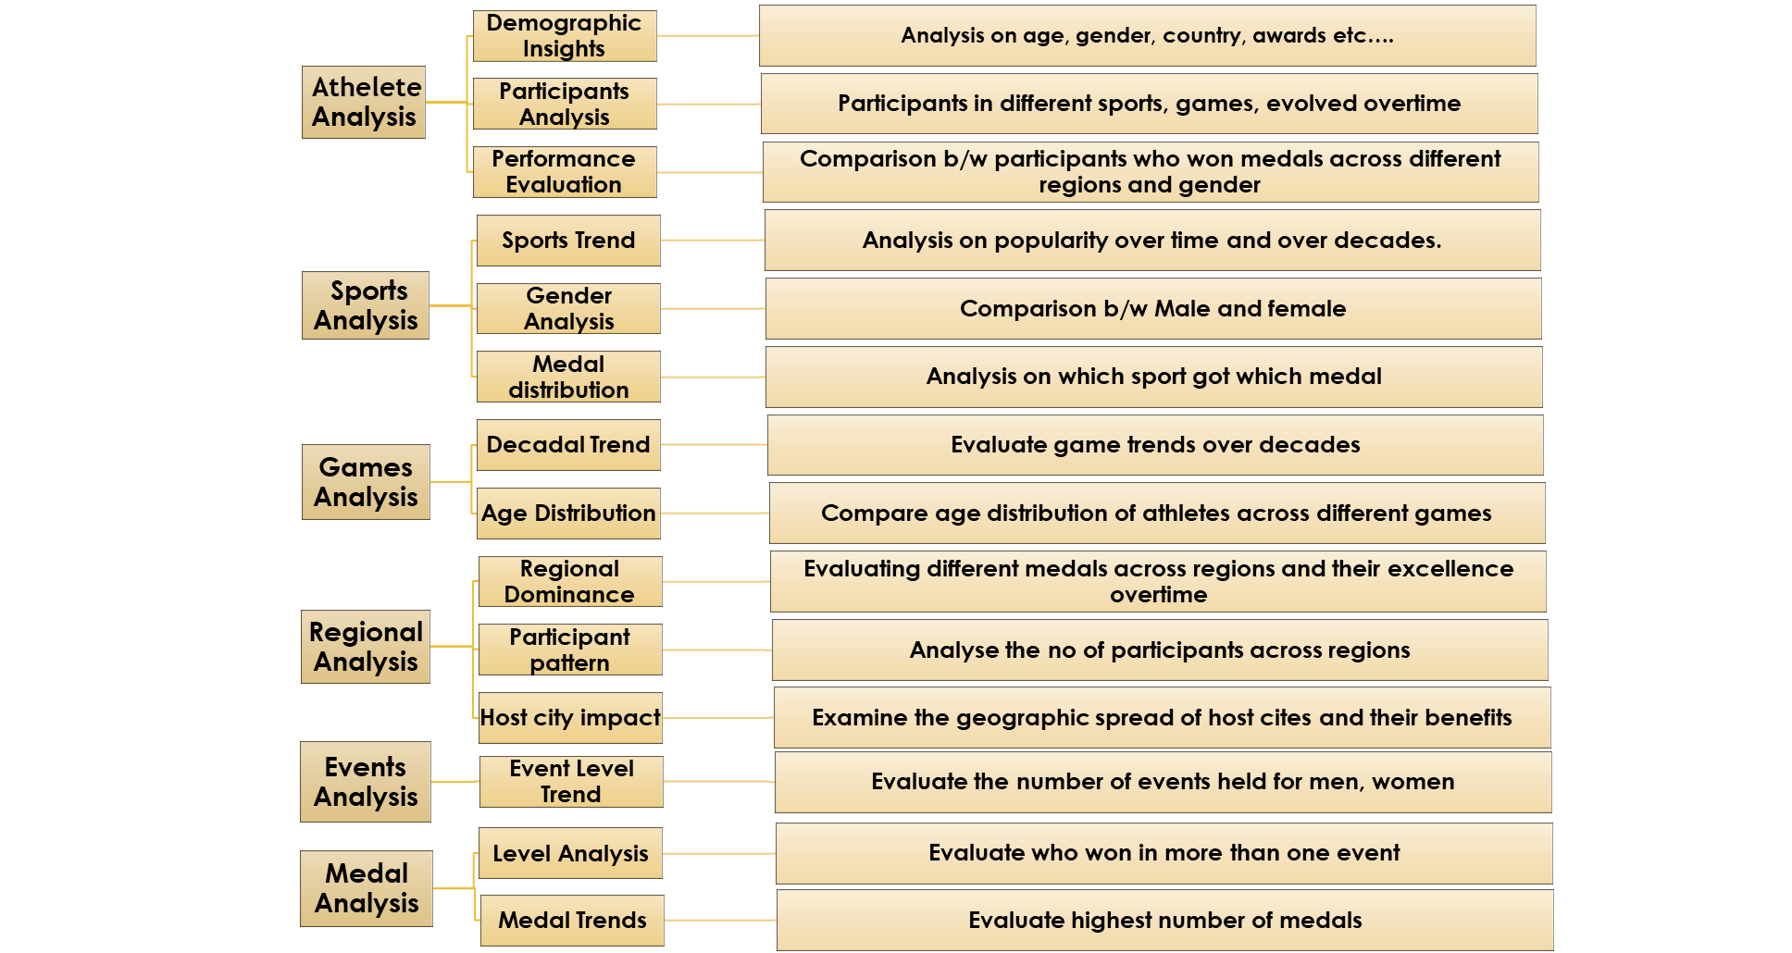

**EDA Questions:**

1. **Are there any trends or patterns in the frequency of hosting Olympic Games?**

**Conclusion:**

Some cities, like London, Los Angeles, and Paris, have hosted multiple times, indicating their prominence in global sports infrastructure and historical significance.

Hosting was more frequent in Europe during the early 20th century, with a gradual shift to other continents in the 21st century.

Countries in Europe and North America dominate hosting frequency.

**2.How has the duration of Olympic Games changed over time?**

**Conclusion:** The 2020 Tokyo Games faced delays and challenges from the COVID-19 pandemic, but the duration of events remained similar.

**Q3. Are there any notable events or occurrences associated with specific Olympic Games?**

**Conclusion:**

The Olympic Games have witnessed numerous notable events and occurrences that have shaped history. These include record-breaking performances, moments of political significance, groundbreaking inclusions (e.g., gender equality milestones), and technological innovations.

**Q4. Are there any emerging sports that have been recently added to the Olympics?**

**Conclusion:**

Recent Olympic Games have embraced emerging sports, including Gymnastics, Badminton, Judo, skateboarding, surfing, sport climbing, and karate. These additions reflect the evolving interests of younger audiences and global sports culture, ensuring the Olympics stay relevant and inclusive in the modern era.

**Q5. How has the popularity of certain sports changed over the years?**

**Conclusion:**

The popularity of sports has evolved due to societal trends, technological advancements, and media influence. Traditional sports like athletics and swimming remain popular, while newer sports such as e-sports and extreme sports are gaining traction, reflecting shifting audience preferences globally**.**

**Q6. Are there any sports that are specific to a particular region or culture?**

**Conclusion:**

Yes, many sports are deeply rooted in specific regions or cultures

In USA, Uk, France are specific to a particular region.

**Q8. Are there any new events that have been introduced in recent editions of the Olympics?**

**Conclusion:**

Recent Olympic editions have introduced new events like Gymnastics, Badminton, Judo, Speed skating, etc….

These additions aim to enhance diversity, gender balance, and audience engagement, keeping the Games dynamic and modern.

**Q10. Are there any notable trends in the height and weight of participants over time?**

**Conclusion:** EDA reveals notable trends in the height and weight of Olympic participants over time, varying by sport and discipline.

For instance, athletes in sports like basketball and volleyball tend to be taller, while weightlifting shows trends toward higher body weight.

**Q9. Are there any events that have been discontinued or removed from the Olympics?**

**Conclusion:**

Several events, such as tug-of-war, cricket, and polo, have been discontinued from the Olympics due to declining popularity, logistical challenges, or lack of global participation. These decisions reflect the evolving focus of the Games on widely recognized and practiced sports.

**Q13. Are there any countries that consistently perform well in multiple Olympic editions?**

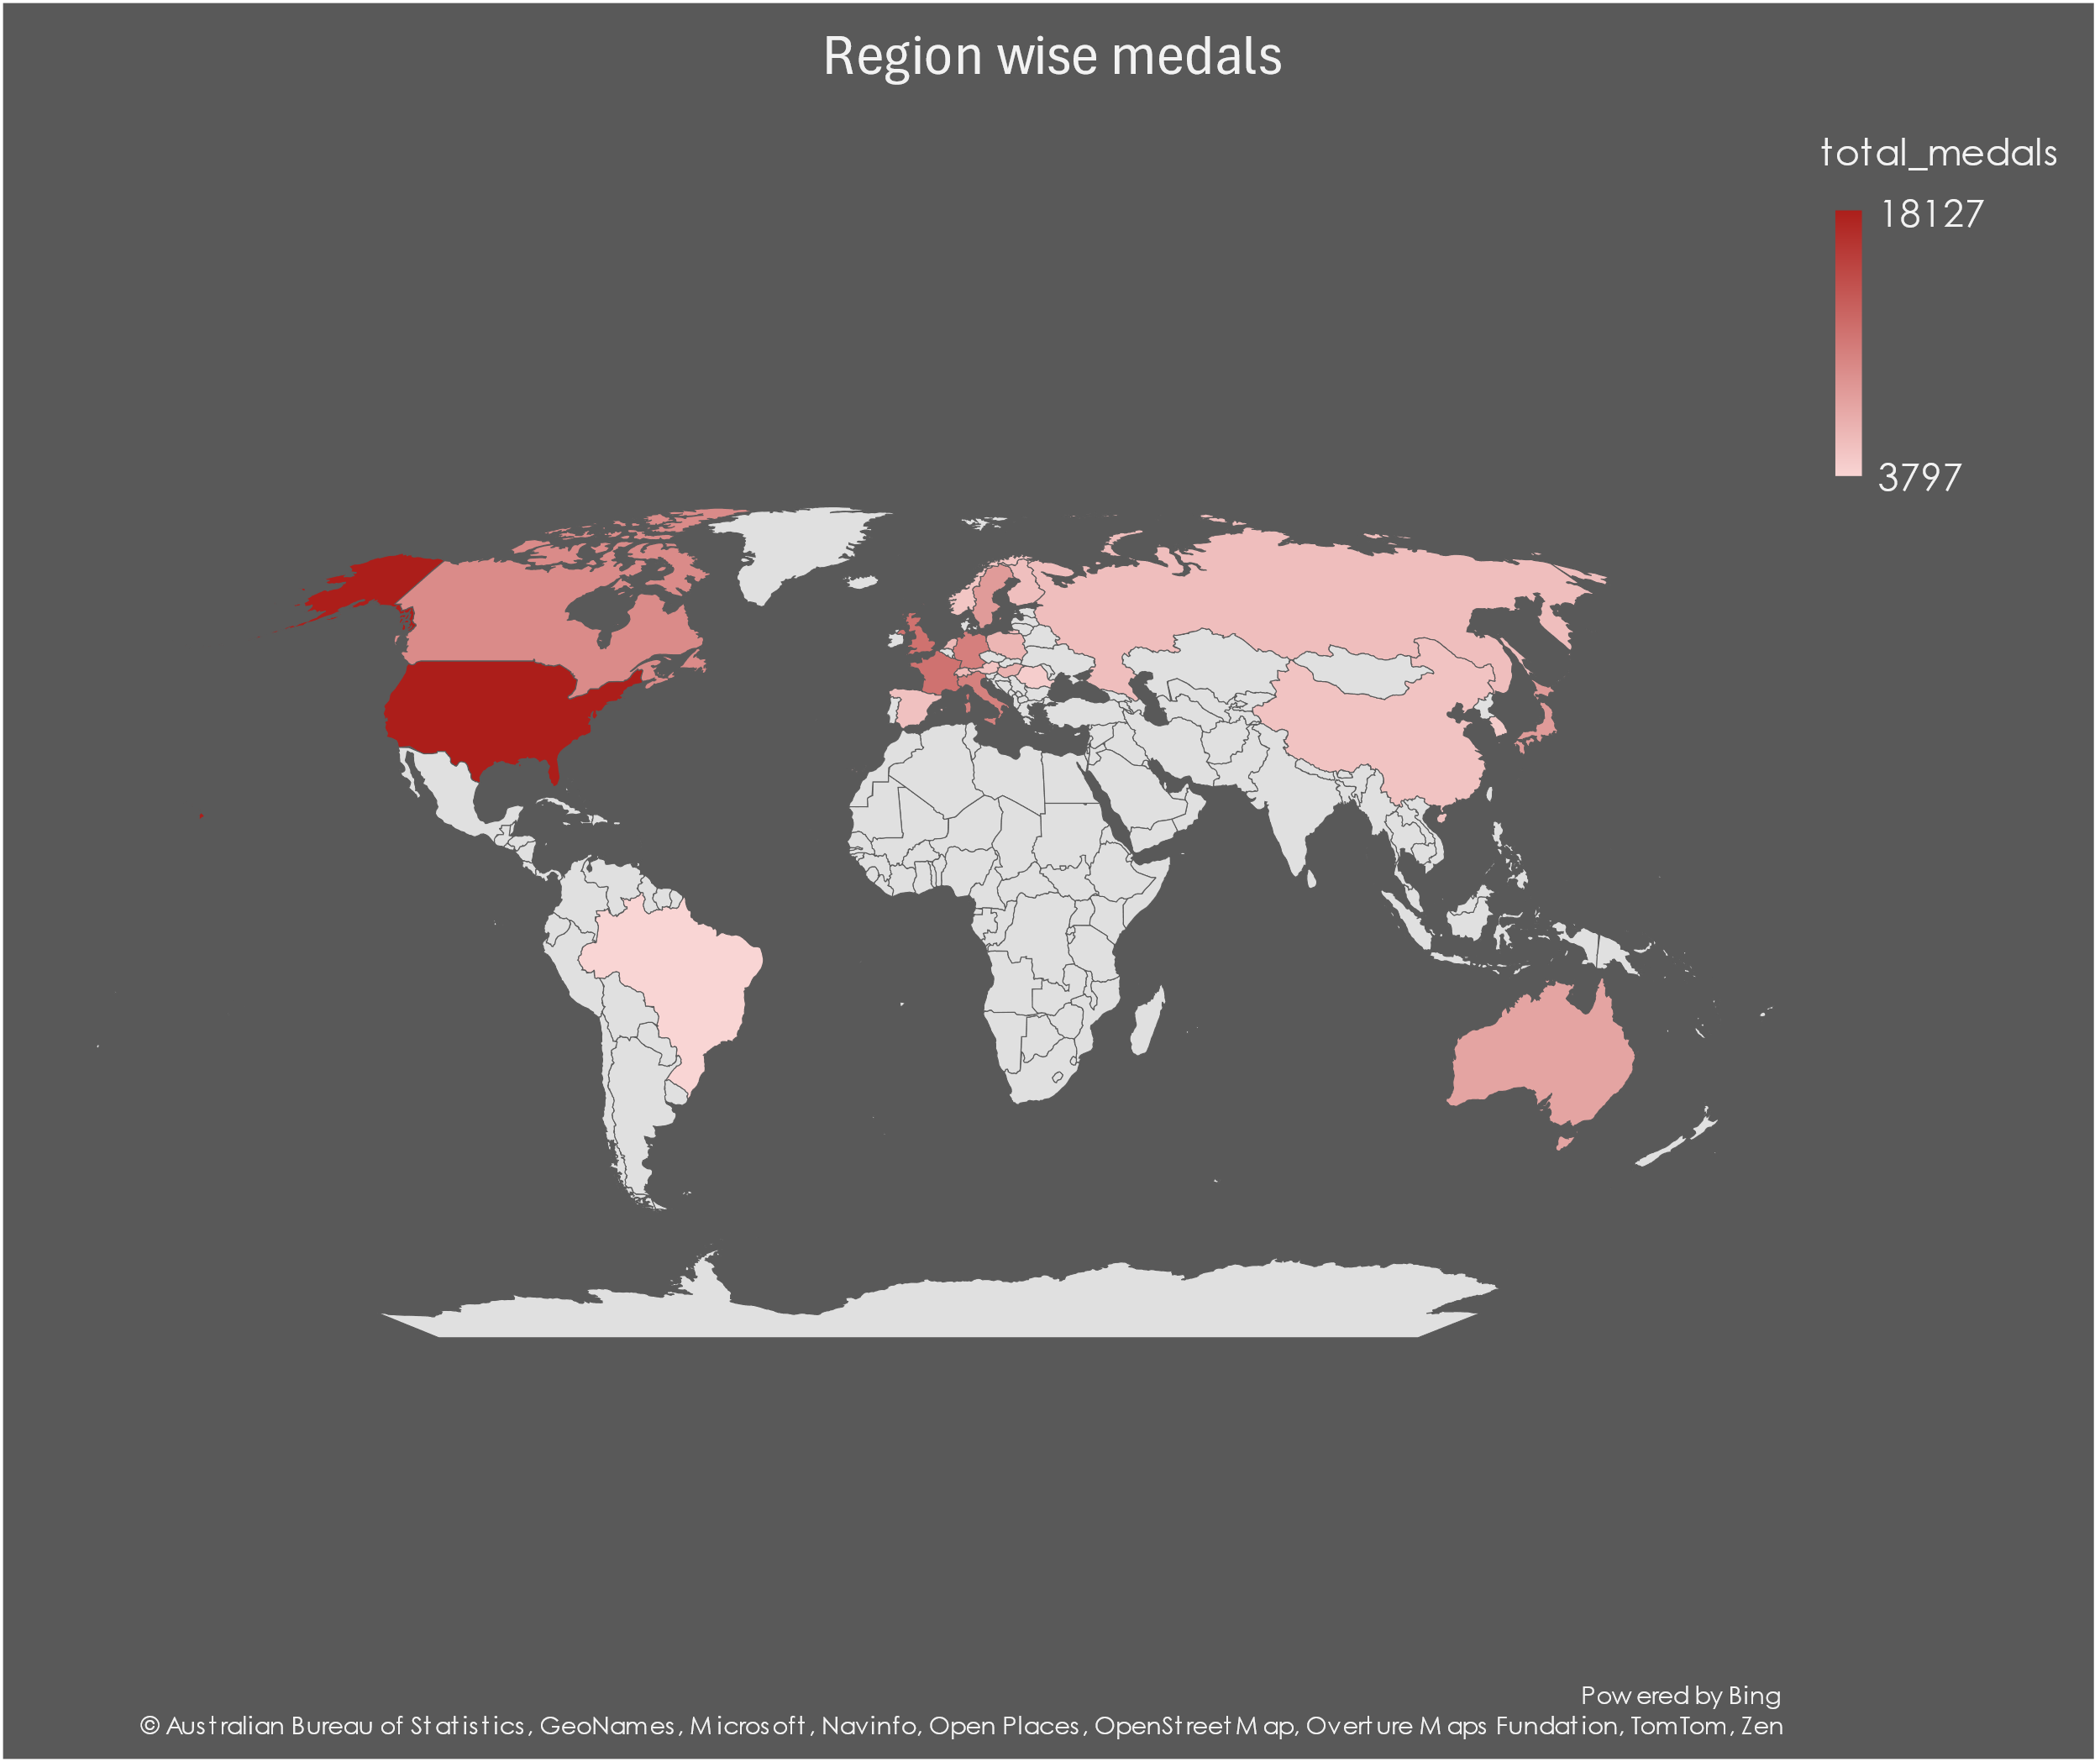

Conclusion: EDA reveals countries like the USA, China, and Russia consistently performing well across multiple Olympic editions.

**Q11. Are there any dominant countries or regions in specific sports or events?**

Conclusion:

EDA highlights specific countries or regions consistently dominating certain sports

USA excels in swimming and athletics, China leads in table tennis and gymnastics, and European nations dominate soccer and cycling.

These trends reflect historical, cultural, and resource investments in these sports by respective countries.

**Q14. Are there any sports or events that have a higher number of medalists from a specific region?**

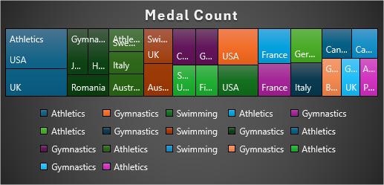

**Conclusion:**

EDA shows that certain sports have a higher number of medalists from specific regions.

Athletics in USA and UK have got the highest Medal count.

**Q16. Are there any regions that have experienced significant growth or decline in Olympic participation?**

**Conclusion:**

EDA shows significant regional trends in Olympic participation, with regions like Africa and Asia experiencing substantial growth due to improved infrastructure and athlete development.

USA have the significant growth rate among different countries.

**Q18. Are there any regions that have had a notable impact on the overall medal tally?**

**Conclusion:** Identified regions with consistently high medal tallies.

Analyze trends over time to see whether any regions are emerging or declining in influence.

**PowerBi Questions:**

**Q1. How many Olympic Games have been held in each season (Summer vs. Winter)?**

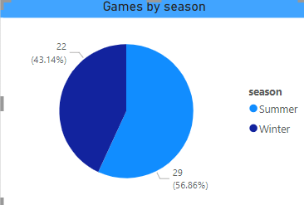

Q2. **What is the distribution of games across different decades?**

**Q3. Which cities have hosted the most Olympic Games?**

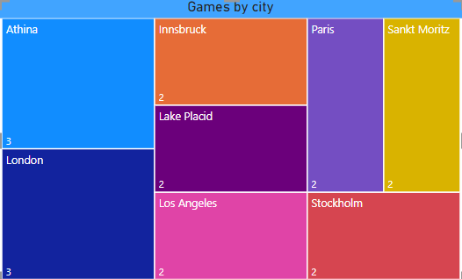

**Q4. *What is the distribution of sports between the Summer and Winter Olympics?***

**Q5. Which sports have the highest number of events in the Olympics?**

**Q6. How has the participation in each sport evolved over time?**

**Q7. How many events are there in each sport?**

**Q8. What is the distribution of events by gender (Men, Women, Mixed)?**

**Q9. How has the number of events changed over time?**

**Q10. What is the distribution of participants by gender?**

**Q11. Which countries have the highest number of participants in the Olympics?**

**Q12. How does the age distribution of participants vary across different games?**

**Q13. How many medals have been awarded in each Olympics?**

**Q14. Which countries have the highest number of gold medals?**

**Q15. How does the medal distribution vary across different sports?**

**Q16. How many regions or NOCs participate in each Olympic Games?**

**Q17. Which regions have the highest number of participants in the Olympics?**

**Q18. What is the distribution of medals among different regions?**

**Summary:**

* **The Olympics include a wide range of sports, divided into categories such as aquatics, athletics, team sports, and individual sports.**
* **An increasing number of countries and athletes participate in the Olympics.**
* **Representation has grown across continents, with emerging nations gaining visibility in global sports.**
* **Certain countries dominate specific sports (e.g., the U.S. in swimming, Kenya in long-distance running).**
* **Medal counts often correlate with a nation's investment in sports infrastructure and athlete development programs.**
* **This type of analysis typically informs decisions on policy, athlete training, and investments in sports infrastructure.**

**Thank you,**

**Thejaswini Ireddy.**